

**IRONMAN**

**DoubleClick**

**Banner   
Management   
Guide**

Editor:  
Tanja Jesse

May 2021

Table of Content

**1. RED ZONE** 3

1.1. What is the Red Zone? 3

1.2. Red Zone Creatives 3

1.3. Receiving and Storing 4

1.4. Process of Uploading 5

1.5. Report Request 10

1.6. What else to consider 12

1.6.1. Back Up Banners 12

1.6.2. Creating a new order 13

1.6.3. Creative or Click-Through-Link Update 13

**2. PROCESS OF TARGETING EVENT PAGES** 17

2.1. Contact Person per Region 17

2.2. Banner Spots on Desktop and Mobile 17

2.2.1. How to add Banner Spots to Website 17

2.3. Pntn and Pagenodetags 18

2.4. Pntn and Pagenodetags in DoubeClick 19

**3. REGIONAL & GLOBAL BANNERS** 23

3.1. Partnership 23

3.2. Merchandise 23

3.3. Evergreen 25

3.4. What else to consider 26

# **1. RED ZONE**

## What is the Red Zone?

The Red Zone consists of **two ad spots** and is found directly on [www.ironman.com](http://www.ironman.com). These creatives are visible on desktop and mobile **globally** and need to be updated once a week.

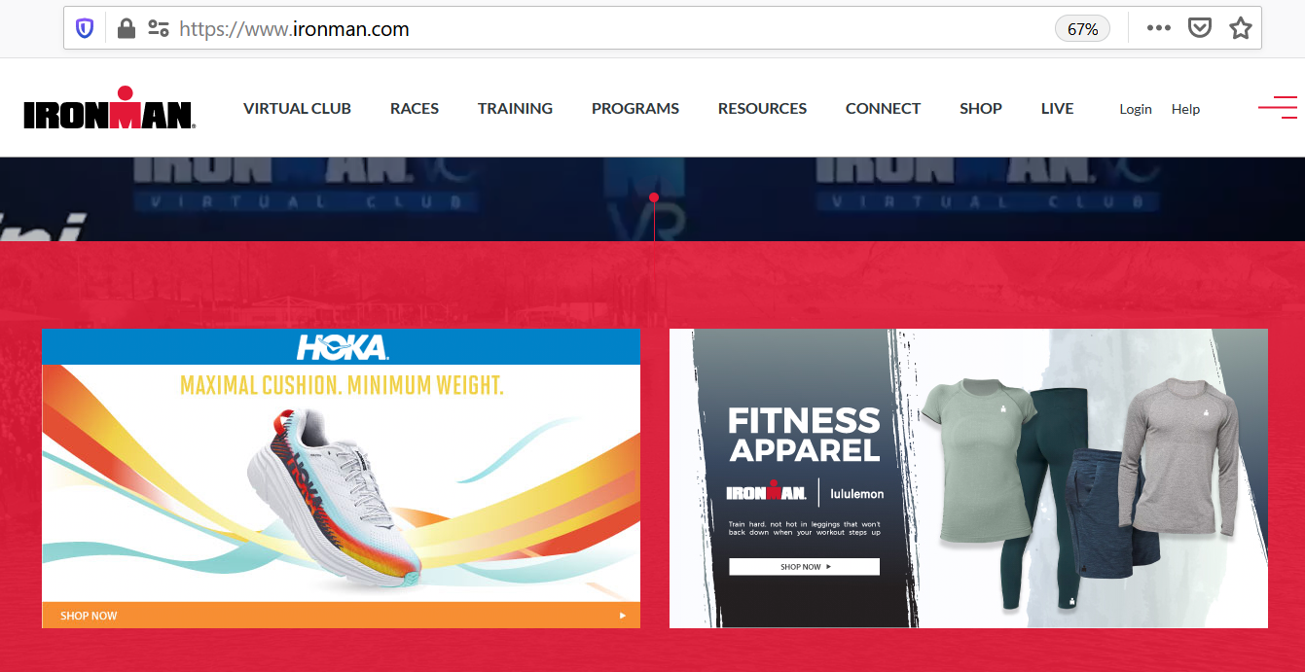

**Red Zone creatives on desktop version**

## Red Zone Creatives

Since these creatives are shown on desktop and mobile, two different dimensions are needed when uploading them:

* **Desktop: 615 x 308**
* **Mobile: 323 x162**

Furthermore, the left spot/block (= Pos 2) is dedicated to **Partnership** content (e.g. HOKA) and the right spot/block (= Pos 3) is dedicated to **Marketing** or **Merchandise** content.

As we geo target the creatives globally, we have separated them into **5 regions** - meaning in total there are 10 creatives to be updated every week.

* **Asia**: all countries in Asia
* **EMEA**: all countries in Europe, Middle East and Africa
* **NA**: all countries / states in North America
* **Oceania**: Australia and New Zealand
* **RoW**: all countries from Asia, EMEA, NA and Oceania are excluded here

Since we have already assigned every country globally to one of these five regions and also added the piece of codes in order the creatives get delivered to the Red Zone ad spots, there is nothing to change / add for you in the ‘Ad targeting’ part (e.g. screenshot from Asia – Pos 2):  
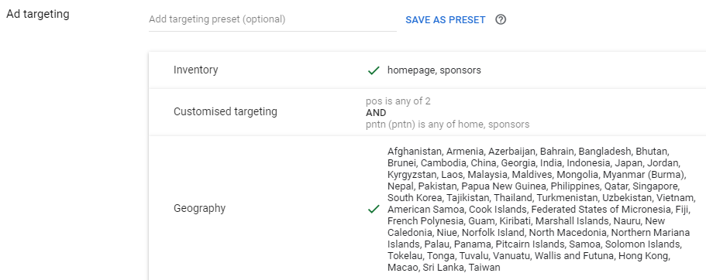

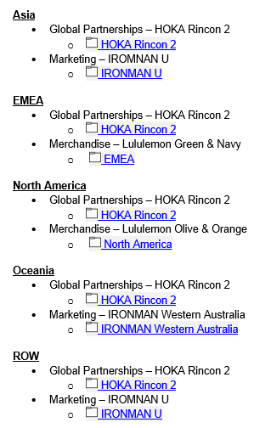

## Receiving and Storing

Every week (mostly Wednesday, Thursday or Friday) **Tyler McCune**

collects creatives + click through links from Partnership, Marketing

or Merchandise and sends them to you via email. As seen on the right

he splits them already up into the regions and again into Partnership

(Pos 2 / left block) and Marketing / Merchandise (Pos 3 / right block).   
After receiving them from Tyler, download the creatives to your computer.   
  
Suggestion for an easy overview system on your computer: I have one folder for every week, in this folder I have one folder per region – in total 5 folders - and in every of these folders I have two more folders for each position (see below).

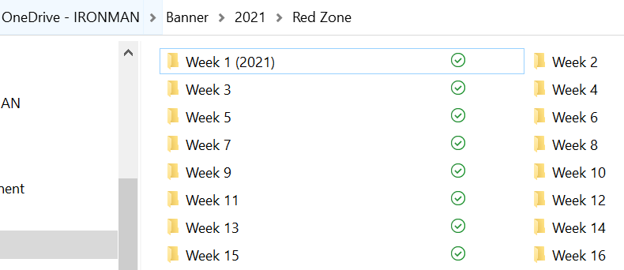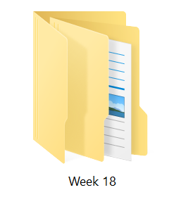 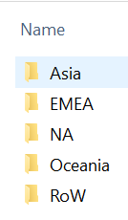 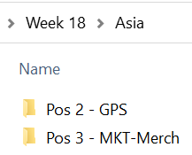

## Process of Uploading

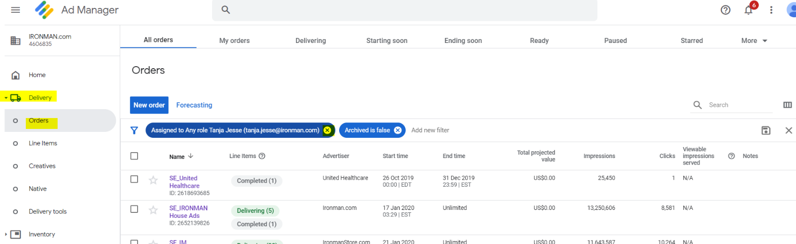Head over to **DoubleClick** and on the left sidebar click on ‘**Order’** located below ‘Delivery’. Click on the ‘X’ where it says ‘Assigned to Any Role name (email address). Once you have created orders by yourself, they will show here in a list – otherwise it’s just blank.

Afterwards click into the ‘Search’ function on the right side and enter ‘**Home’** to search for the correct order.

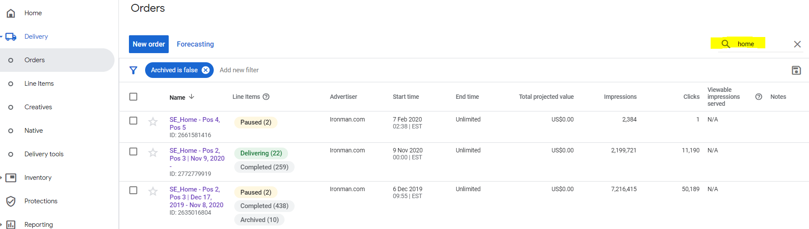*Please Note:* In the screenshot below you see two orders for Pos 2 & Pos 3 (= Red Zone), because ne order can only have **450 line items** in it. This means once you have reached this limit, you need to create a new order. That is the reason why we have added the start and end time to the orders (e.g. SE_Home – Pos 2, Pos 3 | Dec 17, 2019 – Nov 8, 2020). For the future please always keep the naming as it is so it is consistent.

Click on the order where you want to upload the next set of Red Zone creatives. As we have a bunch of line items in the order, I suggest clicking in ‘Add new filter’, click on ‘Status’ (you may need to scroll down or enter ‘status’), tick on ‘Delivering’ and finally click ‘Apply’. You get then a list of all currently delivering line items.

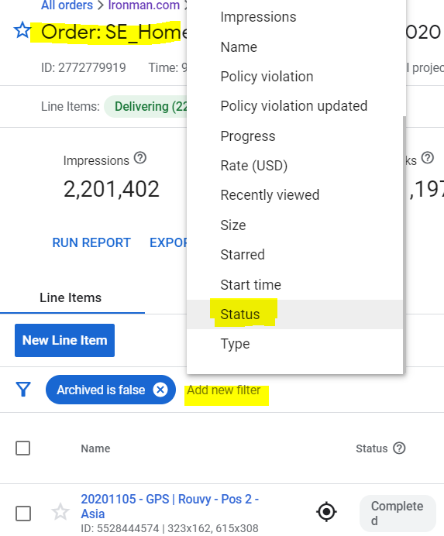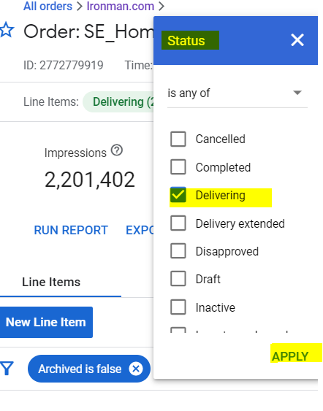

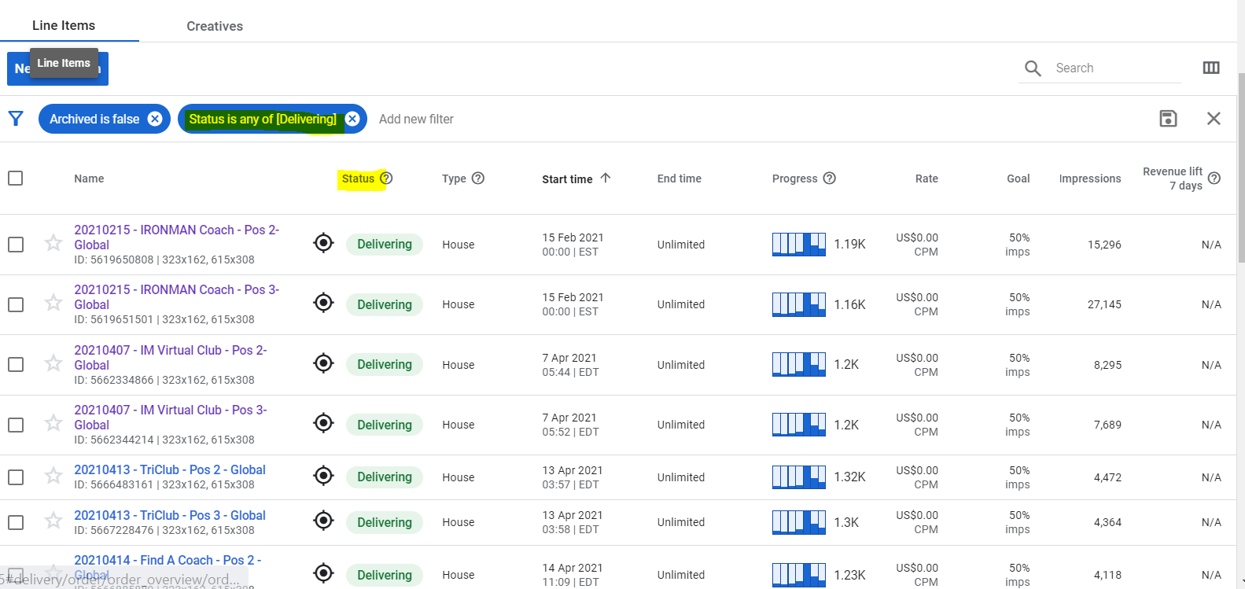

You can start with updating every region for position 2 and then position 3 or you go through the regions, whatever is easier for you. Therefore, open the line item you want to update in a new tab.

In the right corner you see three dots, click on them. You see a little window pop up and click on ‘Copy to..’. Again, a new window will pop up and here you select to copy this line item without creatives as you mostly need to upload new ones.

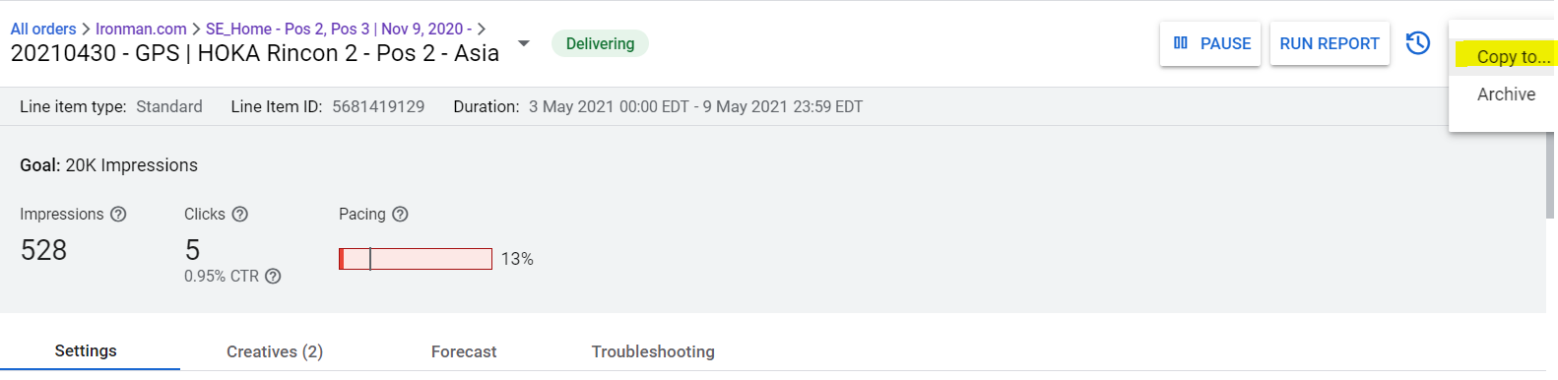

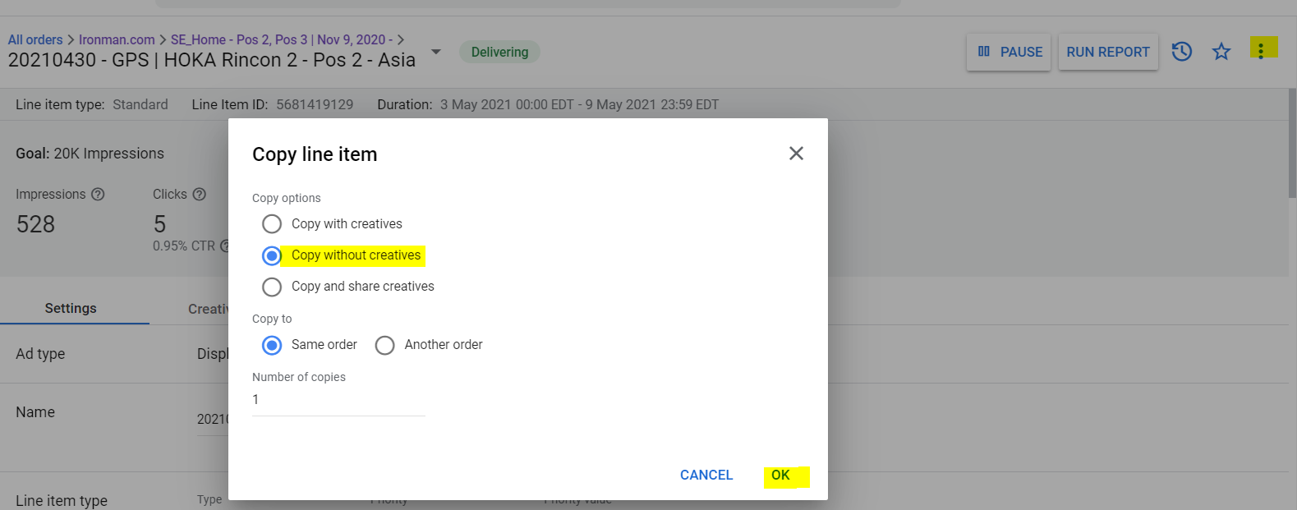

After you copied the line item, you need to change the following parts within ‘Settings’ tab:

1. **Name**: Here you adapt the date – it should always say the date when you updated it and the name of the Brand/Creatives. You see the name always in Tyler’s email. Last thing is to delete the (copy) part at the end of the name. GPS = Global Partnership (Pos 2 / left block) | MKT = Marketing / Merch = Merchandise (Pos 3 / right block)
2. **Start and End Time within ‘Delivery Settings’**: Every line item starts on Monday 00:00 and ends Sunday 23:59 ET.
3. 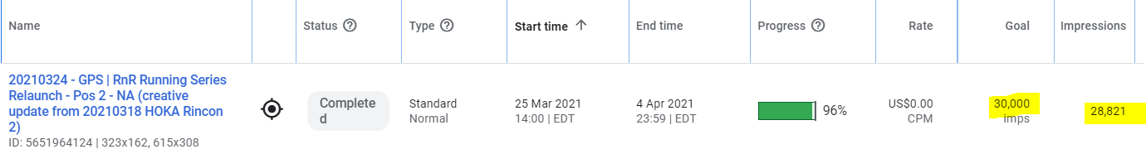**Quantity**: It is set to 20,000 impressions and I think there is no need to change it to lower or higher. In cases where one line item is set to be online longer than a week, you might need to adapt it though. This was the case e.g. with the promo creatives of the RnR Relaunch:

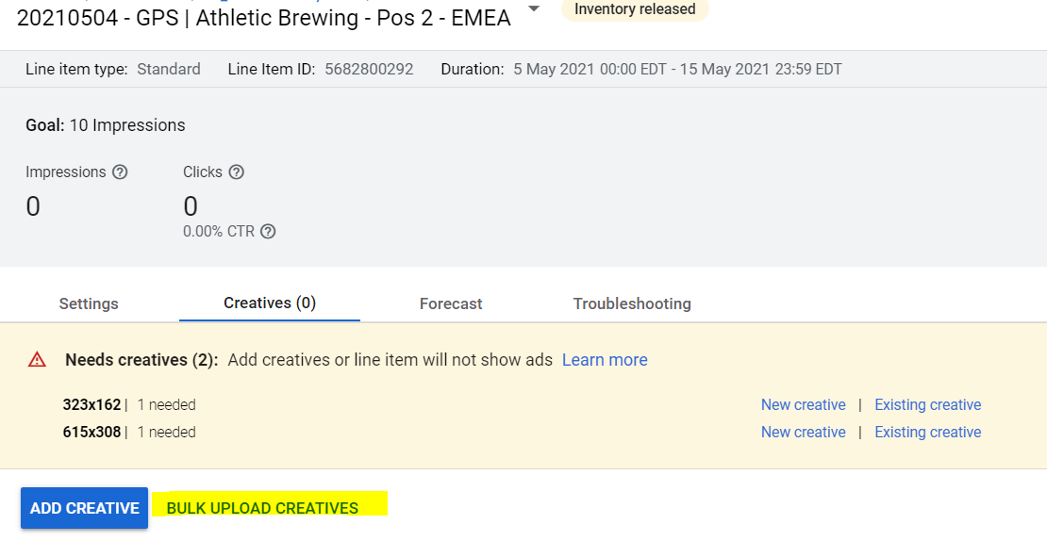After you have changed the necessary parts, click ‘Save’ at the bottom of the page and then go to the ‘Creatives’ tab. Click ‘Bulk Upload Creatives’, then via ‘Browse’ search for the correct creatives on your computer.

Select them and once they are uploaded, click on ‘Continue’ to add the Click Through Links.

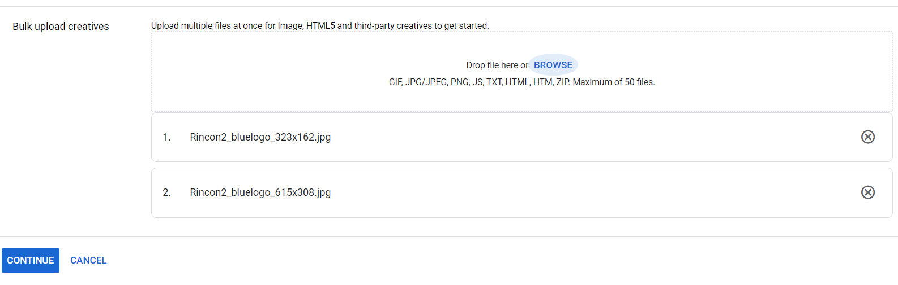

Add the link once for desktop and once for mobile version. Click on ‘Save’ and afterwards make sure to click on ‘**Resume’** in the right top corner. A pop up might appear with a ‘Overbooking warning’, simply click ‘Save’.

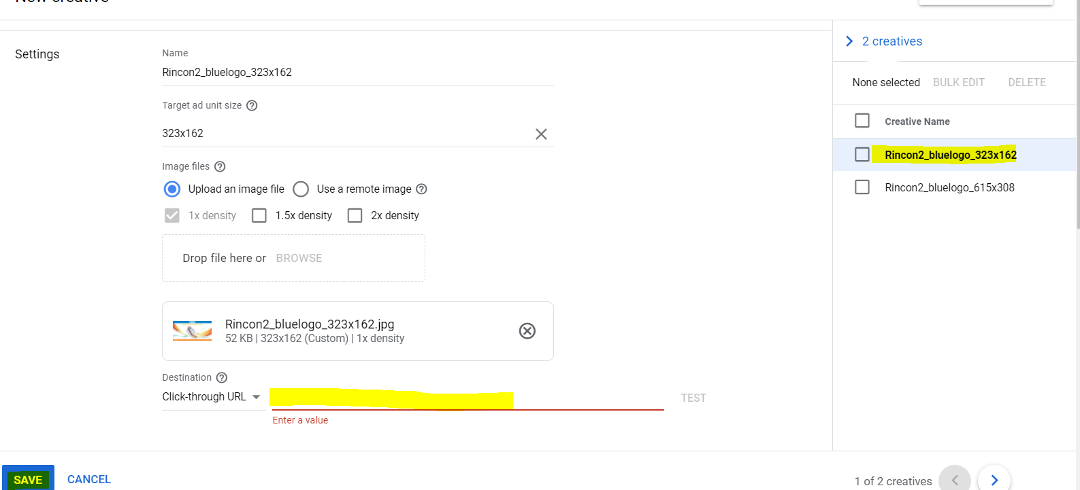

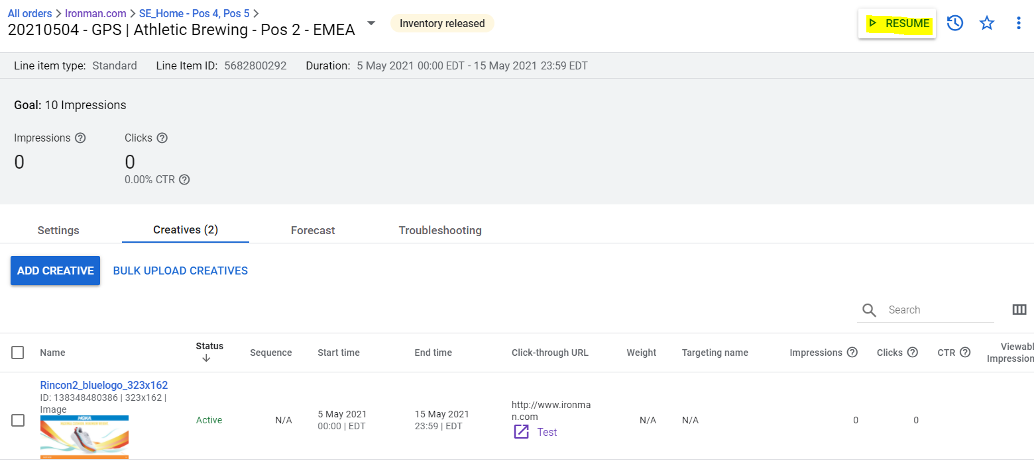

It needs to be ‘**Ready’** (instead of Inventory Released) next to the name of the line item and ‘Pause’ where it was ‘Resume’ before.



Repeat with all other nine lines times 😉

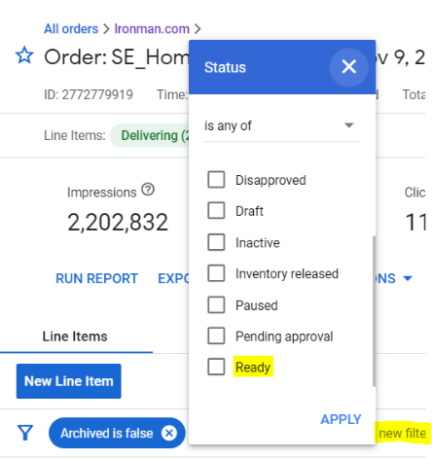***Note****:* Sometimes it happens that the same creatives + link will be used twice in a row. If this is the case, you also copy the line item, but this time you select ‘Copy with creatives’ (e.g. often the case with Pos 3 / Marketing of Oceania). You still would need to adapt a) the name (only date) and b) start end end time!

Once you are done with all 10 line items, head back to the order and via   
Add a filter > Status select ‘Ready’ You will get a list of all line items  
you copied/adapted before. This gives you a chance to doublecheck  
if everything is correct.

Make a screenshot of these then line items as seen below and it to Tyler so   
he is aware too that everything in the Red Zone is ready and scheduled for the next week.

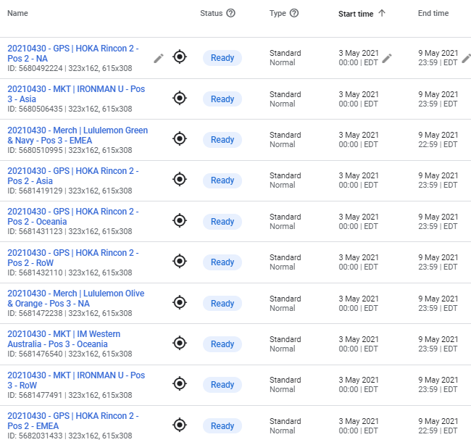

## Report Request

From time-to-time Tyler requests a report of the Red Zone. He usually mentiones he would like to have them until a certain date. Let’s say he would like to have them through the week of March 8, 2021:

1. In DoubleClick you find ‘Reporting’ in the menu on the left, click on it and a drop down opens, where you click on ‘Reports’. After clicking on ‘New Report’ you need to fill in the necessary info.
2. Fill in the **name** of the report (we always go with the date we create it, then SE (for SportsEngine), Home (for Red Zone Homepage), Pos 2 and 3 (for the positions of the creatives) and some attributes).
3. Afterwards we set a **fixed date range**, we always go from Jan 1, 2020 until the date Tyler requests. In this case through the week of March 8, 2021 = Jan 1, 2020 – March 14, 2021.
4. Select the Table structure to ‘**Hierarchical’**.
5. And maybe the most important one to set the **correct filters**, so we get a report of the Red Zone creatives. Click into ‘Add filter’ and search and select ‘Order’. Then type in to search for our ‘Home’ orders, as of May 2021 we have two orders, therefore we select both.

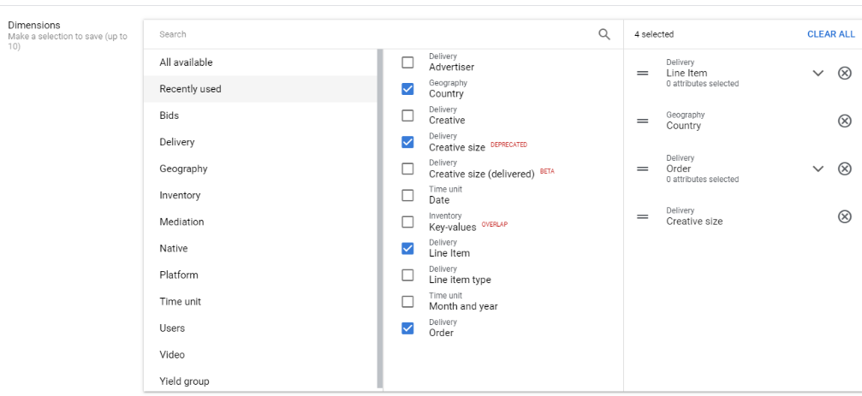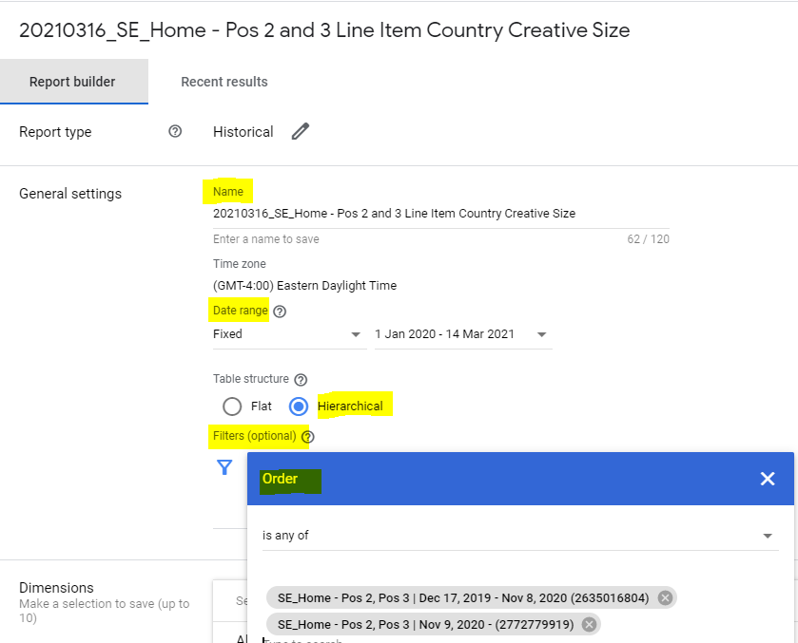

1. In the ‘**Dimension’** part we select the following ones: Country, Line Items, Creative Size and Order.
2. 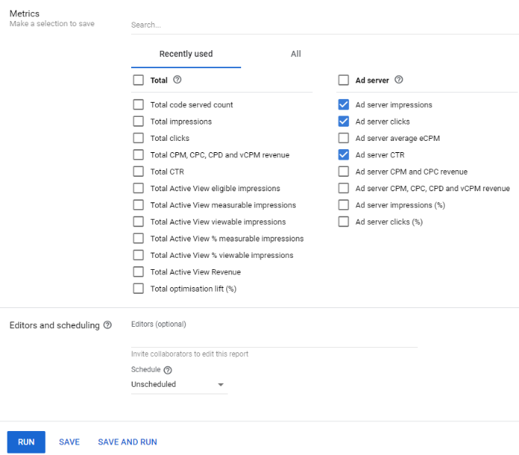Further down in the ‘**Metrics’** part select Ad server impressions, Ad server clicks and As server CTR. Finally click on ‘Save and Run’, this means DoubleClick will run the report AND save this template, so next time you only have to adapt the date of request, time range and possibly the order if there will be already three orders.
3. Last thing export the results in xlxs.
4. Sometimes we add a **Pivot Table** to the Excel file. You can check with Tyler first if this is necessary.   
     
   If so, go in the Excel file to the ‘Report Data’ tab and then under ‘Insert’ choose ‘Pivot Table’. After creating the Pivot Table you will find it in an own tab. Add ‘Country’ to Filters, ‘Creative Size’ to Columns, ‘Line Item’ to Rows and ‘Ad server impressions’ to Values. Save it and send it back to Tyler.

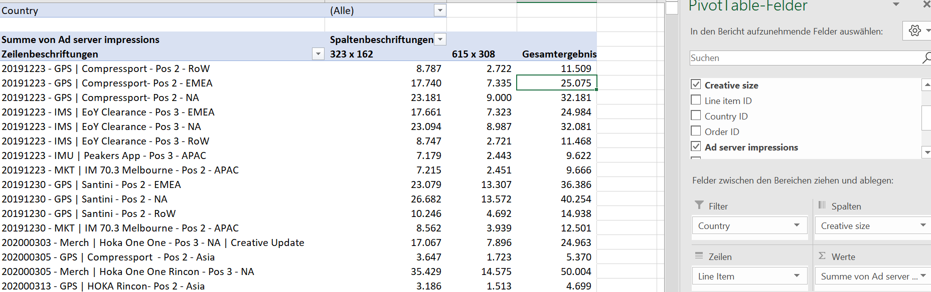

## What else to consider

## Back Up Banners

As of May 2021, we have six different back up banners uploaded as **House Banners**\* to the Red Zone in order to avoid blank spots in case something comes up. In the Progress tab you see that they are mostly delivering from Sunday to Monday when the creatives change. I have set the ‘Goal’ to 50% of the remaining impressions, I don’t know what’s the perfect percentage, I often just try it out.

The six banners include AWA, IRONMAN U, Be A Coach, Find A Coach, IRONMAN Virtual Club and TriClub. These are **evergreen** banners, so there shouldn’t be anything to change in the near future. In case someone requests a creative / link update or there is the need to pause the line item, they will reach out to you.

**\*** House Banners have their end time automatically set as ‘Unlimited’ and a lower priority to get delivered as our Partnership / Merch Red Zone Creatives, which are Standard types. [Read more about line item types here >>](https://support.google.com/admanager/answer/177279?visit_id=1620204123247-4490414570319294231&rd=1)

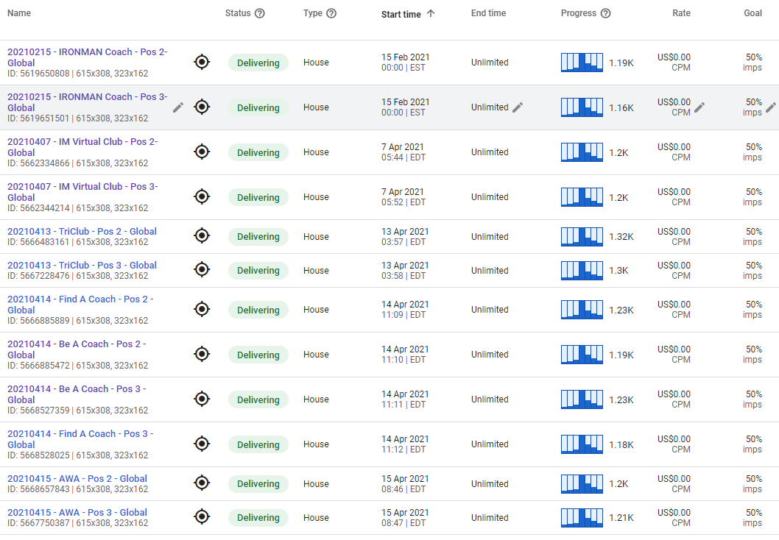

## Creating a new order

When the currently used order is full with 450 line items, you need to create a new order. Therefore, click on ‘New order’ button which is above the line items.

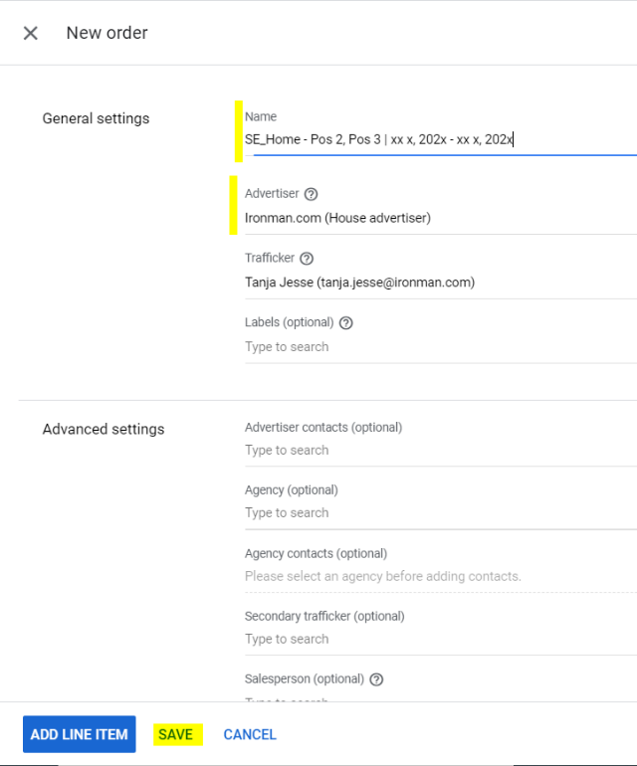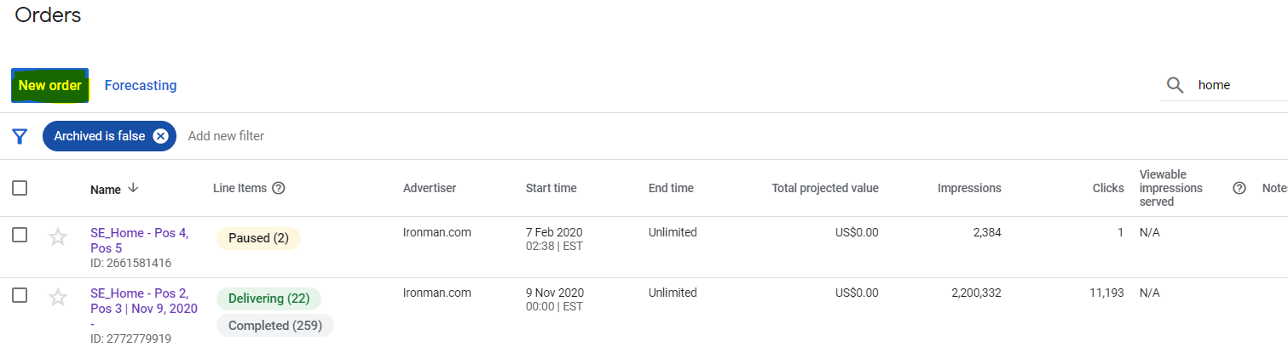

Then you get to a new window where you need to add   
the **name of the order** and who the **advertiser** is. In this   
case you can ‘spy’ on the other orders who the advertiser   
is: ironman.com. When you have filled out the necessary  
 info, click on ‘Save’.

***Please Note:*** Keep in mind that once you have clicked   
‘Save’ you can’t change the advertiser of  
 the order anymore! The name of the order is changeable   
though.

Afterwards you need to approve the order - you find the  
‘Approve’ button above the list of line items. It is in the same spot where you clicked ‘New Order’ before.

## Creative or Click-Through-Link Update

Sometimes there will be ‘special requests’ to change click through links or even to update creatives of the currently delivering line items of the Red Zone. These requests should come from Tyler or if not, we need to align with him.

***Change of Click-Through-Link***In case there is only a click-through-link change requested, whereas the creative stays the same, we head to the Line Item where we need to do this and go to the ‘Creatives’ tab. We tick on the box next to ‘Name’, so both creatives are marked and click on ‘Copy creatives’. Both creatives are now copied and visible underneath. We can then tick of the two marked creatives.

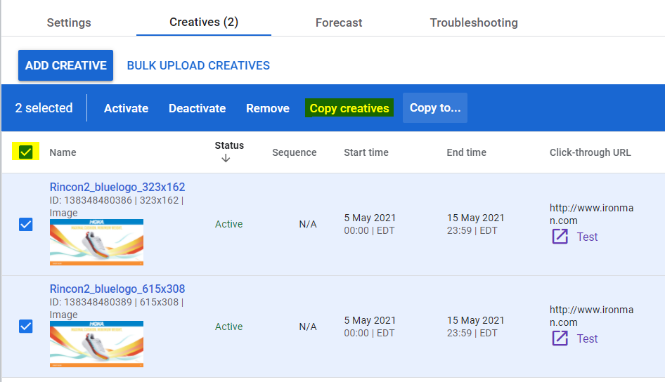

The **newly copied creatives** need to be adapted for a) Start Time (change it to the time you are updating it) and b) Click-Through-Link.

The ‘old creatives’ need to be ticked on again and afterwards deactivated by clicking od ‘Deactivate’. Instead of deactivating it would be possible to adapt the end time of the creatives accordingly.

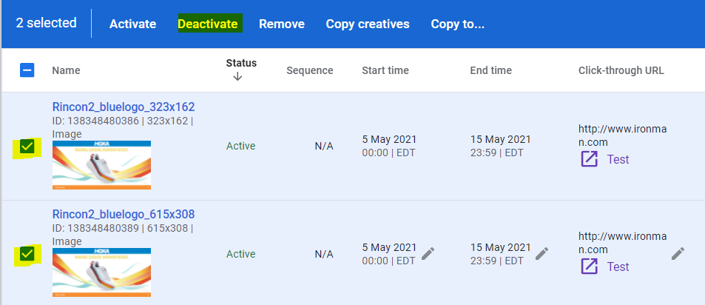

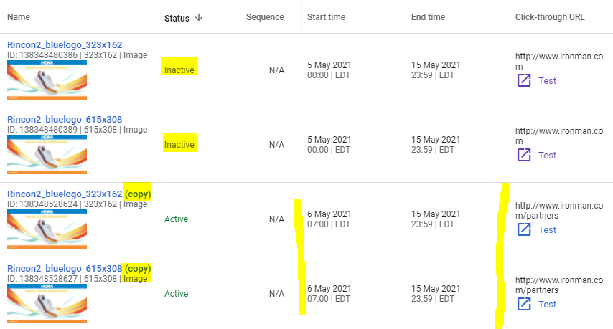After it is done I would a screenshot of the creatives  
from the ‘Creatives’ tab (as below) and send it back to Tyler / Merch to let them know that the old creatives are deactivated, and new ones should be deliver any time now.

***Change of Creative***  
If a request comes in to change the creatives of a line item, there are two possibilities.

1. If it is a **creative update of the ‘same brand’** – meaning we have a HOKA line item delivering and there is a request to change the HOKA creatives to different HOKA ones – we head again to this line item and to the ‘Creativess’ tab. We upload the new HOKA creatives via ‘BulK Upload Creatives’ and add the Click Through Link. The Start Time should be adapted automatically to the time you do this, but better to doublecheck start & end time ;). Afterwards we need to deactivate the ‘old creatives’.
2. If it is a **creative update from a different brand** – meaning e.g. we have a HOKA line item and the request is to change them to UTMB World Series ones – we copy this line item without creatives and adapt name, start + end time and creatives + CTR link. In case Tyler (for Partnership topics) or someone from Merch doesn’t mention it, check in with them for the new start time of the creatives.  
     
   For the name I usually try to make it clear that it is a creative update and write the date of when I change it, adapt brand name and in brackets I add (Creative update from yyyymmdd name of former line item -> e.g. *20210505 – GPS | UTMB World Series – Pos 2 – NA (creative update from 20210430 - GPS | HOKA Rincon 2 - Pos 2 – NA).* Then go to creatives, upload the new creatives + link and click on ‘Resume’.  
     
   This means the new creative is ready to deliver and therefore we need to adapt the old line item. Ideally you change the end time accordingly so it’s a smooth transition. Afterwards I head back to the order, go to the status and tick on ‘Ready’ and ‘Delivering’, make a screenshot and send it back to Tyler / Merch so they know that the creative update is done.

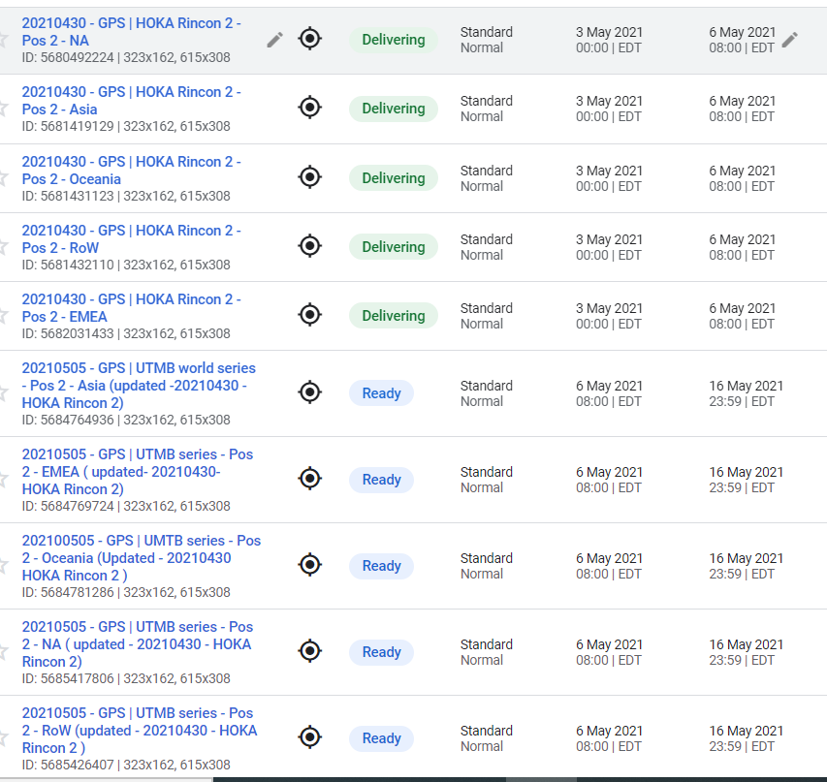

The reason to not write over current links / creatives / line items is simply to keep track of the already delivered number of impressions and click through rate.

# **2. PROCESS OF TARGETING EVENT PAGES**

In order for banner creatives to show on the event pages we need to make sure that banner spots are enabled on every event site (incl. subpages) and afterwards assign every single event page a piece of code. As of May 2021, we have **two banner spots** (dimensions: **300x250**) on desktop as well as one **sticky banner for mobile** (dimension: **320x50)** on the event pages.

## 2.1. Contact Person per Region

* **Asia:** Vera Tan
* **EMEA:** Tanja Jesse
* **NA (incl. LATAM):** Yanel Pinto
* **Oceania:** Rudi Weber

## 2.2. Banner Spots on Desktop and Mobile

The banner spots on desktop are located on every event page underneath the menu on the left, whereas the mobile banner is a sticky one and always visible when you scroll down.

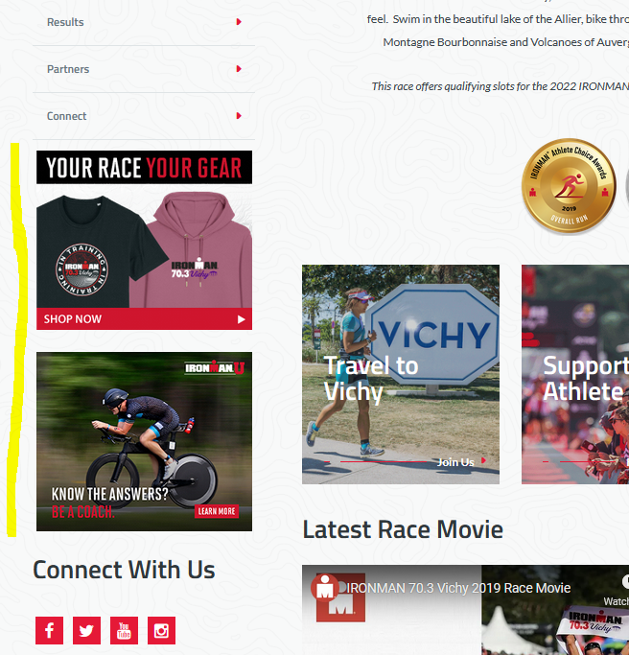 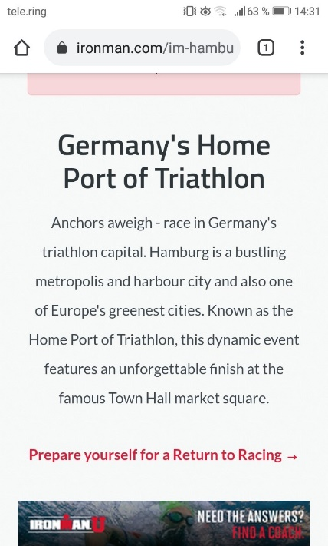

## How to add Banner Spots to Website

***Desktop***If you do not see the banner spots on race pages, it is highly likely they have not been added. It can be added very easily when you go into edit mode of the page and then to ‘Options’. Here you click ‘Edit Page Details’ and where it says Bottom Template you need to select ‘**Live Page Left Rail’** and click save. Repeat with all further subpages of this page. You will see the newly added banner spots immediately on the pages if you go out of edit mode.

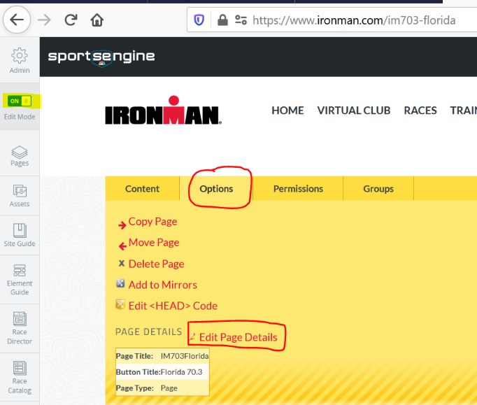 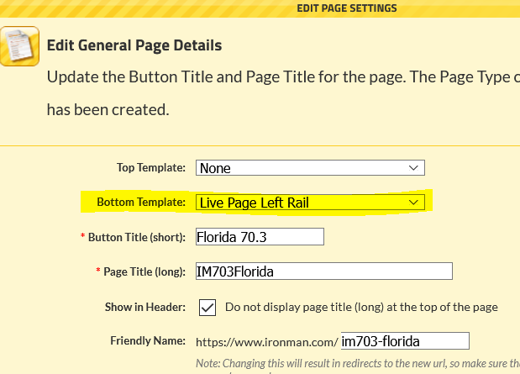

***Mobile***For mobile we have a code that needs to be added to the pages, but first it needs to be checked where on the pages to add, e.g. with NA* and Oceania the code should have been added to the ‘Premier & Technical Partners’ template at the bottom of the pages (see screenshot below), while in EMEA it is added as a mirrored layout container on every single page.   
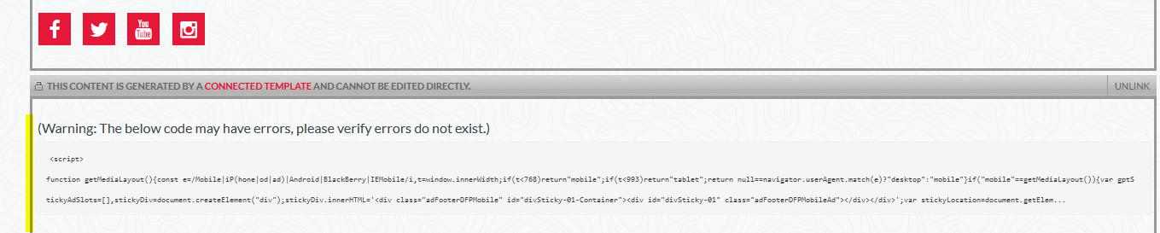

*(currently no code with 5150 Mont-Tremblant, 70.3 Calgary, 70.3 Muskoka -> maybe to add via race header connected template)

As of May 2021, the code is not yet added for **LATAM** and **Asia** -> for Asia to check with Vera first.

Whenever new races are launched, a) banner ad spots should be enabled and b) the mobile code should be added on all pages too.

## Pntn and Pagenodetags

After adding the banner ad spots on desktop + mobile to the event pages, we need to add some **pieces of information** - **pntn** and **pagenodetags** - per every single page to DoubleClick.

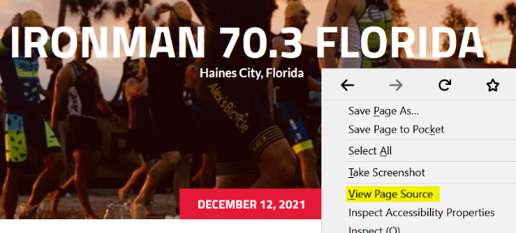***Pntn***Head to the page and click on the page with the right mouse tab and from the pop-up choose ‘**View Page Source’**. A new window opens, and you see the page source of this page. Search for ‘**pntn’**.

The pntn will always be the **race name**: for an IM race e.g. austria | for an IM 70.3 race e.g. florida-70-3 | for an 5150 race e.g. mont-tremblant-5150.

On the ‘Home’ pages we always need to get both the pntn (race name) and pagenodetag (piece of numbers).

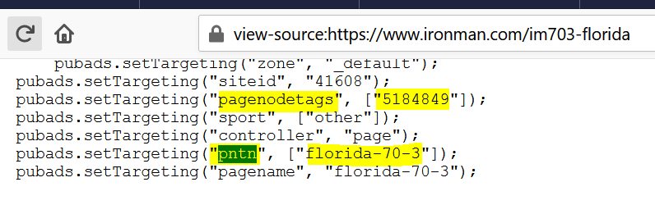***Note:*** If you do not find any pntn or pagenodetags when searching for it via the page source, it means the banner ad spots are not added to the page (see *2.2.1. How to add banner spots to website*)

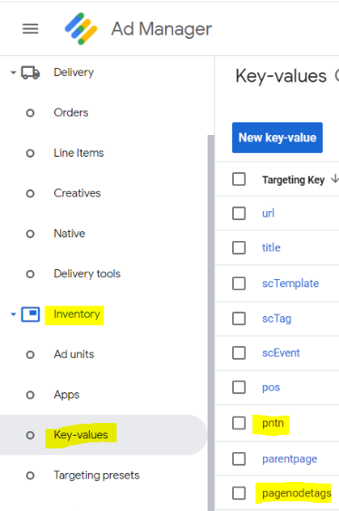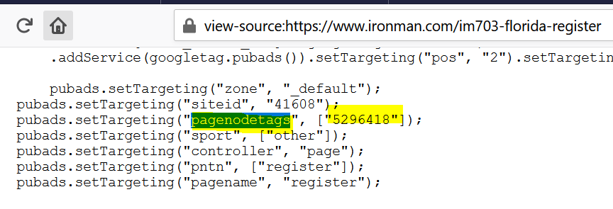 ***Pagenodetags***For **all subpages** (Register, Course, Athletes, Supporters, Travel, Results, Partners, Connect) we get the **pagenodetags** (piece of numbers) only. The pntn on subpages refers to register, course etc. in general, meaning DoubleClick would target ALL Register pages instead of only e.g. 70.3 Florida Register Page.

## Pntn and Pagenodetags in DoubeClick

To add pntn and pagenodetags to DoubleClick, we click ‘**Inventory’** on the left menu and then go to ‘**Key Values’**.

***Pntn***Go into ‘pntn’, click on ‘New values’ and add paste pntn code on the right where it says ‘Create targeting value’. Click on save and done.

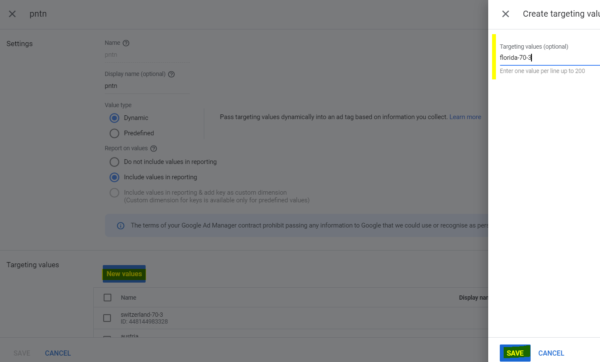

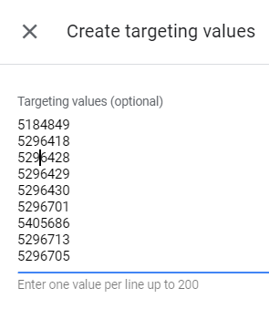 ***Pagenodetags***It is the same procedure to add the pagenodetags. Go to ‘Pagenodetags’, click ‘New values’ and add the numbers. Here you can add all nine numbers per one event (= ‘Home’ + eight subpages) at the same time. Please remember to make a screenshot of the numbers before you click save. The reason is that you need to search for each number afterwards to assign it a display name (= race name).   
  
To do this check the number via the search function on the right and if the numbers is found, click on the pencil underneath Display name. Add here the name of the race, but you don’t need to differ between the subpages (e.g. im703-florida-register). In the end there should be 9 pagenodetags all with the same Display name (see second screenshot below).   
 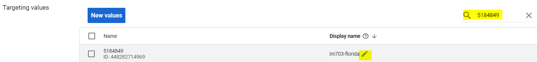

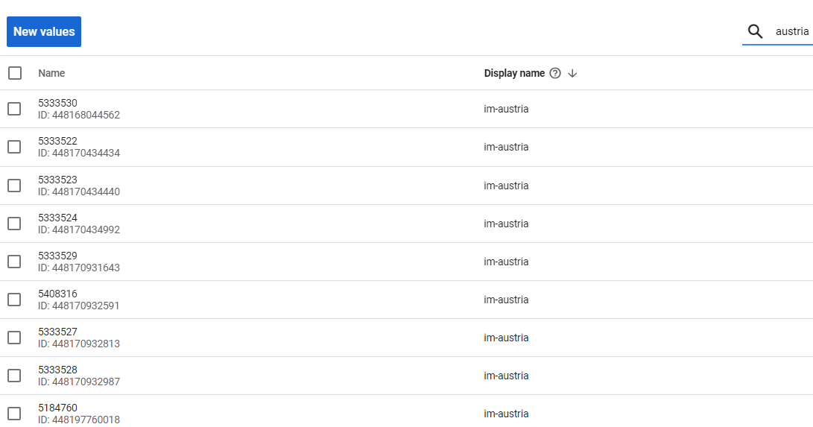

***Presets***Once you have added the pntn and all 9 pagenodetags as new values, you go to ‘Targeting Presets’, which you find just below ‘Key-Values’ in the ‘Inventory’ dropdown menu on the left. There are several targeting presets, which are **groups of combined targeting** that can be used to target banners e.g. per region.

As of May 2021, we have **groups of 5150’s, 70.3 and IM per region + groups of all races per region**. Since we have owned and licensed races in Europe, we separated them into different groups. The ones titled ‘AsiaEurope’ are countries which are located in Asia, but belong to the EMEA region (e.g. Russia, Kazakhstan). To distinguish them from races of the Asia region, we add them to AsiaEurope groups, while races from the Asia region go into ‘AsiaAsia’ groups. Other_EuropeOwn consists of small European races that do not fit to any of the three distances (4184’s + Company Triathlon, Kalmar Mini Tri).

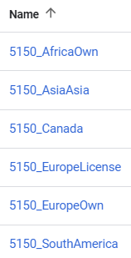 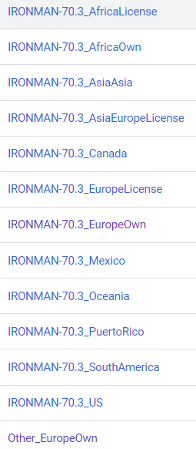 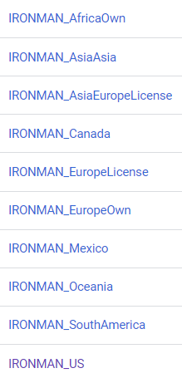 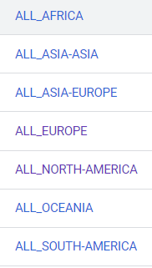

**Every race (pntn + 9 pagenodetags) needs to be added into two groups**: once to the group if its distance and once to the group of all races per region: e.g. 5150 Kraichgau (Germany) goes to ‘5150_EuropeOwn’ and ‘ALL_EUROPE’; IM 70.3 Florida goes to ‘IRONMAN-70.3_US’ and ‘ALL_NORTH-AMERICA’; IM Australia goes to ‘IRONMAN_Oceania’ and ‘ALL_OCEANIA’.

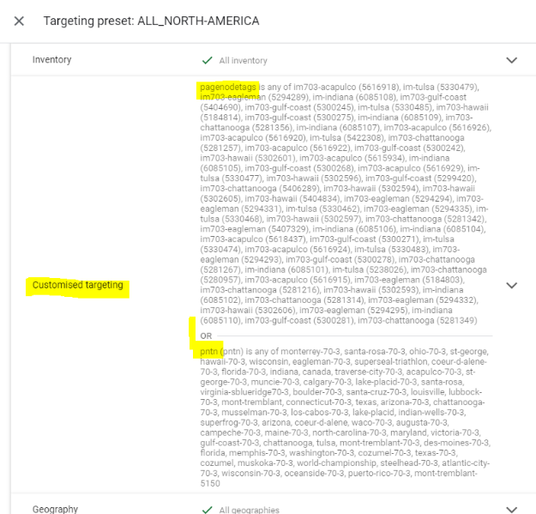

Let’s take IM 70.3 Eagleman, go to ‘ALL_NORTH_AMERICA’ and click into the ‘**Customised targeting**’ field. Where it says ‘pntn is any of’ go to the bottom and start typing the name of the race, when it appears, tick it on. Repeat the same with typing in the race name where it says ‘pagenodetags is any of’ and tick on all nine pagenodetags of this event. Click save. Repeat the same process of adding 70.3 Eagleman to “IRONMAN-70.3_US” group.

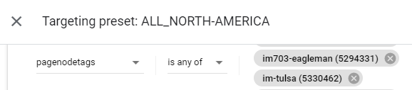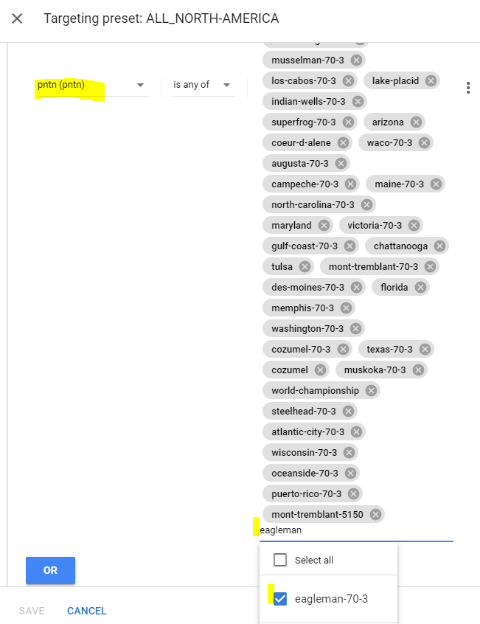

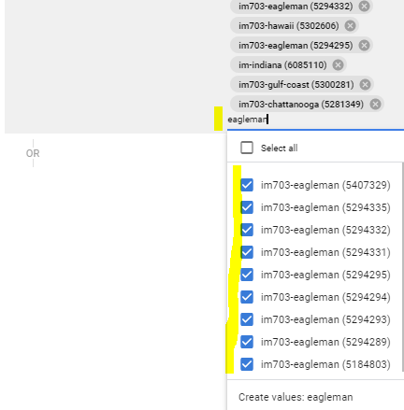

When races are discontinued, we can delete the pntn + pagenodtags from these groups.

# **3. REGIONAL & GLOBAL BANNERS**

Besides the Red Zone Banners that need to be updated every week, there are also Partnership, Merch and Evergreen banners that need to be taken care of.

***Contact Person per region:***

* **Global + NA**: Yanel Pinto (is taking care of NA and Global banners)
* **EMEA**: Tanja Jesse (is taking care of EMEA banners, that are only delivering in EMEA and nowhere else)
* **Asia**: Vera Tan (as of May 2021 there are no banners that are only delivering in Asia)
* **Oceania**: Rudi Weber (is taking care of Oceania banners, that are only delivering in Oceania and nowhere else)

Based on the name of the order you know from which region it originally came from -> e.g. EMEA_SE_ | NA_SE_ | Oceania_SE or only SE (for Red Zone, Merch, Evergreen).   
We always add SE for SportsEngine, so we can differ between orders that were delivering on our old CMS system (Sitecore) and SportsEngine, which we use since November 2019. Oceania has a few orders with no SE in their name, meaning they are not delivering on SportsEngine, but on another platform.

## 3.1. Partnership

Besides Red Zone, Merchandise and Evergreen banner, the below Partnership banners are online and delivering as of May 2021. Based on this screenshot only two orders came through EMEA (Maurten and Santini), whereas the rest was requested by the NA team.

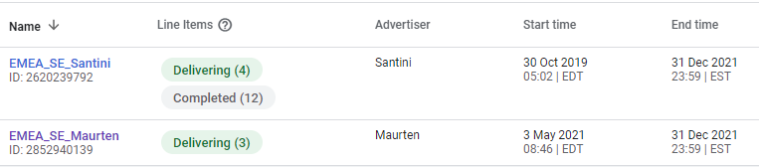

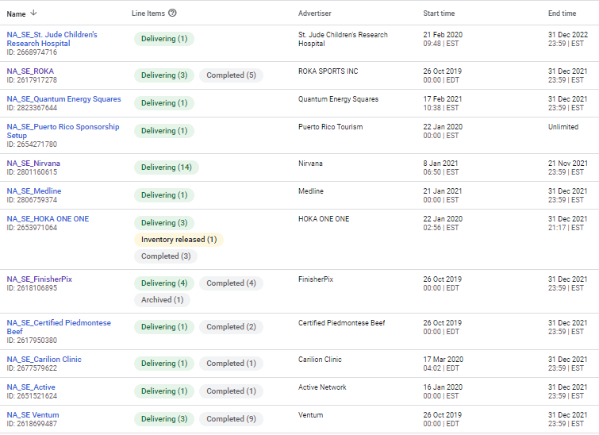

Contact Persons per partner:

* **Brett Olsen:** Nirvana, ROKA, Carilion Clinic
* **Tyler McCune:** Medline, HOKA, Active, Ventum, St. Jude Children’s Research Hospital, Certified Piedmontese Beef
* **Jess Glover (EMEA):** Maurten, Santini
* **Tina James:** FinisherPix
* **Jon Young:** Quantum Energy Squares

*Puerto Rico Sponsorship Setup is an exemption as we ‘moved’ it to SportsEngine during the website relaunch. Unless nobody mentions to end it, it will be online as it has not any end date.*

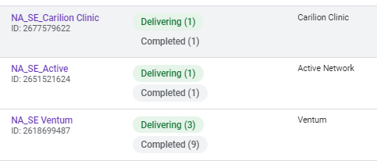  
Mostly in the first quarter of the year the Partnership teams come to you and asks to upload partner banners. Here you need to differ between already existing partners (e.g. Ventum) - where you would add a new line item per year to the Ventum order (NA_SE_Ventum) – or if a new partner comes onboard (e.g. Athletic Brewing as of May 2021), then you would need to create a new order for it *(**see chapter 1.6.2 Creating a new order**).*   
  
***Please Note:*** For Partnership banners the advertiser needs always to be the name of the Partner (e.g. Ventum, Roka, Active Network,...).   
  
The NA team mostly sends the creatives + an excel file with detailed info on how to set up the order / line items.

Let’s take HOKA as an example -> Here I received the creative (only for desktop) and the below info (screenshot from the whole excel file) on start/end times, impression goal, URL and target details.

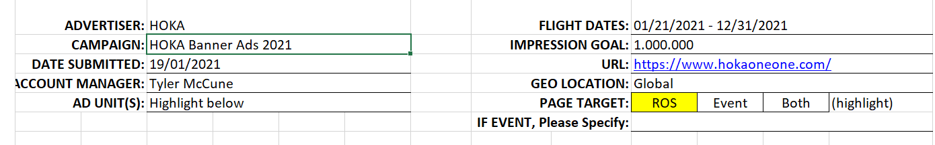

***Things to note:***

* **Impression goal**: 1 Mio impression goal is a lot – especially when we do not have mobile banners.
* **Geo Location**: When they say global, it is always better to check as Asia is often not included in banner orders. In such cases you can either check the existing order on how the set up was for the past year or simply ask if global means EMEA, NA and Oceania OR Asia, EMEA, NA and Oceania.
* **Page Target**: ROS = Running on Site, which was used on the old CMS, but is not possible anymore on SportsEngine. That is why we target mostly region wide.

Although it says ‘global’, we always upload one line item per region – meaning in this case I uploaded three line items: one for APAC (= Asia+Oceania), one for EMEA and one for NA. Once I asked if Asia should be included, I got the answer no. So, I paused**\*** the APAC line item and started to create a new line for Oceania only. Since we have three line items, we also divide the impression goal between these. Due to EMEA and NA having the most events, we give them more impression. Oceania and Asia usually do not do so good impression wise, meaning they get less. Typically, 1 million Impression is split with 400.000 each for NA and EMEA and 200.000 for Oceania.

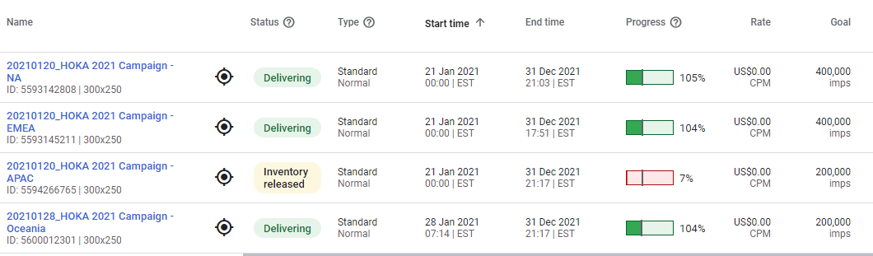

***\**** *whenever we pause a line item, I set it afterwards to ‘Inventory released’. This means that the inventory that was initially ‘reserved’ for this line item, is released so other line items can deliver. This is only possible for standard line items, not for house banners.*

To start uploading / updating, you can either copy the line item from the last year (if there is any) or you click on ‘New Line Item’. Afterwards, we need to add info to the

* **name** (date of uploading_name year – region)
* **Line item type:** this stays as standard with priority normal and priority value 8 for ‘normal banners’. Only for house banners this would change to ‘House’.   
  ***Note****: it is not possible to change the line item type after saving!*
* **Expected creatives**: here we add 300x250 for desktop and in case we have mobile banner too, we add 320x50. If no mobile banner is sent through, it is always good to ask for it since most of our athletes use mobile over desktop (around 60% > 40%).

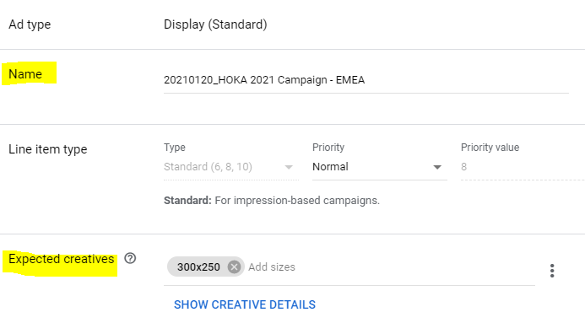

* **Start Time:** Add the start time: the NA team mostly writes it in the Excel file. The EMEA team either writes it in an email or if not, I simply select ‘Immediately’. If you are unsure, just ask back.
* 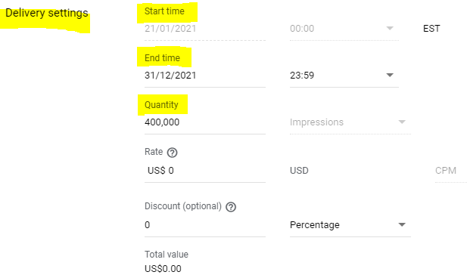**End Time:** Most banners are set to deliver the whole year until Dec 31. Here also, if you are unsure, ask them.
* **Quantity**: The NA team writes it in the Excel file. The EMEA teams often says to give them the same # of impressions of partners the same level. If they say as much as possible, be careful – the partner banners should be valued around the same and we also need to make sure to leave inventory left in case we get more banners / partners.
* 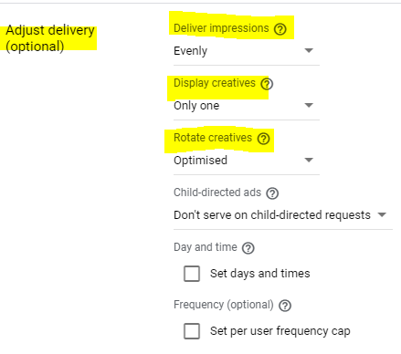**Deliver impressions:** Evenly
* **Display creatives**: Only one
* **Rotate creatives:** optimised

**Ad Targeting**

* Inventory:
* Customised targeting:

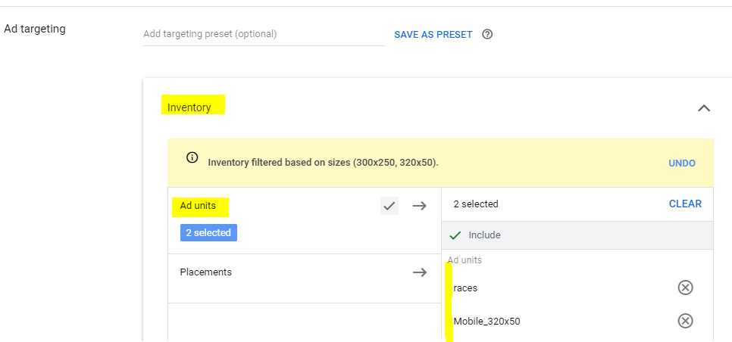

## 3.2. Merchandise

We have an own order for Merchandise banners “SE_IM Store_HouseAds” with advertiser “IronmanStore.com’. As of May 2021, we have a) generic Merchandise banners for EMEA and NA and b) race specific merchandise banners for EMEA and NA races. The goal for all of them is set to achieve 50% of the remaining impressions.

***Generic Merchandise banners EMEA & NA***These banners were sent from Ashley Reynold and Sara Greenbaum from the NA Merchandise team. At the moment, we only have creatives for desktop. All of them are **House banners** and geographically targeted via countries.

While the Generic Store Ad line items are set to an unlimited end time due being a very generic/evergreen creative, the rest of the Merch banners (Face Masks, Ogio Bags) are set to end on Dec 31, 2021. Unless the Merch team reaches out before that time, you could check with them in the beginning of the new year if they want to extend the line item for 2022 and if so, ask them for new creatives to have fresh images.

The ‘Hoka Carbon X’ and ‘Roka 20% off’ line items were not prolonged and for the Santini line item someone from EMEA Partnership team reached out to pause/end it due to having a wring logo on it.

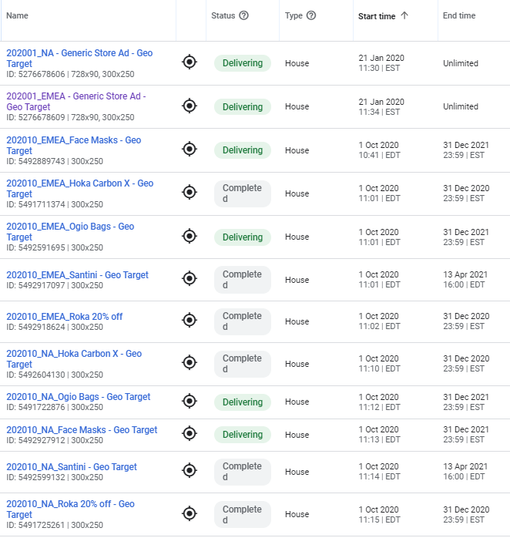

**Race specific merchandise banners**For most 70.3 and IM races in NA and EMEA I received from Sara Greenbaum and Ashley Reynolds race specific merchandise banners (In-Training Apparels) for desktop & generic ones for mobile since the mobile ones are quite small. They are as well set as House Banners with an unlimited end time. Furthermore, they have race specific utm links per every race.

Since they are race specific, the creatives are set to deliver only at the dedicated event website:   
e.g., set-up of IM 70.3 Barcelona:

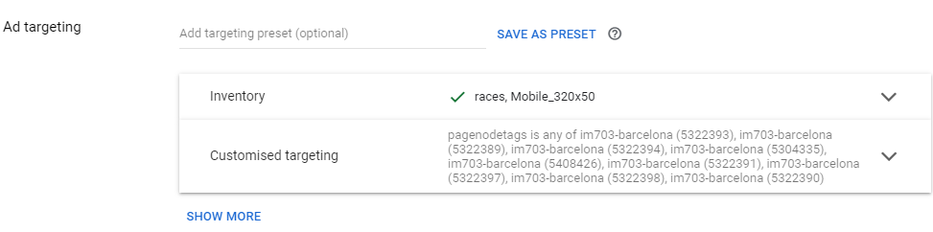

## 3.3. Evergreen

As of May 2021, we have five Evergreen banners delivering, the reason here is mostly to not have any empty ad spots and to promote our own programs. These banners are all set as **house banners**, meaning their end date is ‘Unlimited’ and their advertiser is ‘**IRONMAN.com’**. The goal for all of them is set to achieve 50% of the remaining impressions.   
  
See below for these 5 evergreen banners, that are all delivering **globally**:

* **AWA**
* **IM Virtual Club**
* **TriClub**
* **IRONMAN U - Find a Coach**
* **IRONMAN U - Be a Coach**
* **IM Athlete Tracker App** (Due to covid and not having any races at this time, we set an end date to this line item as house banners cannot be paused. When we are back at events, we )

To appear globally I have selected **races** (for desktop) and **Mobile_320x50** (for mobile) in the ‘Inventory’ of the ‘Ad targeting’ part here = no geographical settings needed.

If possible, it is always better to have banners for desktop (300x250) AND mobile (320x50) to have a bigger reach. The ones uploaded in April were sent by Michael Kupper.

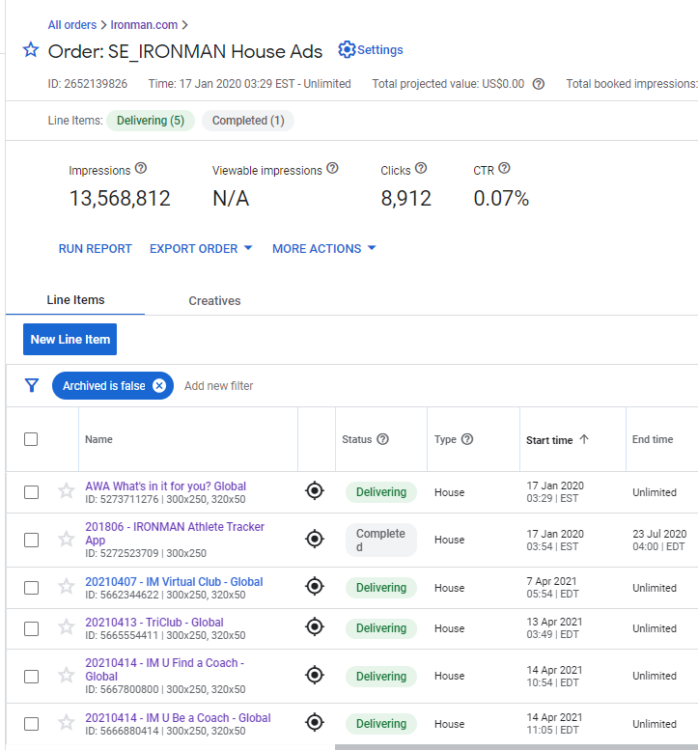

## 3.4. What else to consider

# **4. More infos**

**Impressions** = The number of times an ad from the order has been displayed. It usually takes about  
30 minutes for new impressions to be recorded and added to the total display.

**Clicks** = The number of clicks on line items in this order. It usually takes about 30 minutes for new clicks to be recorded and added to the total display.

**CTR** = The click-through rate, which is the percentage of impressions that result in a click.

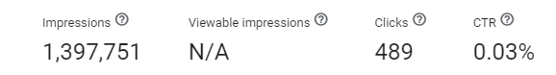

***Adjust delivery***

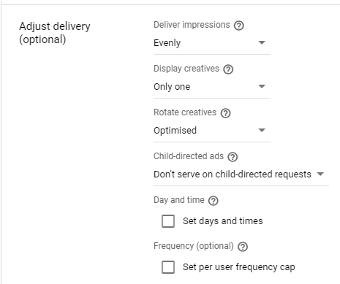

**Deliver Impressions =** This setting can adjust pacing of ad delivery in a line item. The default setting (Evenly) allows Ad Manager to pace ads equally across the start and end dates of a line item. This option is typically the best unless your advertiser requests a different pacing option or you're trying to meet other ad delivery goals.

* **Evenly**: Delivers evenly until the end date—but could deliver up to 5% higher than the goal as a safeguard against underdelivery.
* **As fast as possible:** Never considered "on schedule" and delivers ads as much as possible—tries to use every impression it can get—without compromising delivery of other line items at the same or higher priority. This could result in an early end if the line item's goal is achieved before the end date.
* **Frontloaded**: Begins serving as much as 40% higher than its goal briefly and gradually declines to 5% ahead of schedule toward the end. Sum of impressions during the first half can be as much as 25% higher than expected without frontloading.
* We use mostly ‘Evenly’

**Display Creatives** = When there are multiple active creatives in a single line item, you can use the settings to control how creatives can be displayed on a single webpage.

* **One or more:** When possible, serve multiple creatives in the line item per ad request
* **Only one:** Only serve one creative in this line item per ad request
* **As many as possible:** Prioritizes creatives associated with this line item
* **All:** All creatives must serve to the ad request or not at all
* We use ‘Only one’

**Rotate creatives** = If your line item contains multiple creatives, you can define which creative displays as part of a rotation when the line item is delivered to user. Options include:

* **Evenly**: Each creative is displayed equally at random.
* **Optimized**: Creative with the highest CTR displays more often.
* **Weighted**: Creatives displayed at a frequency you define.
* **Sequential**: Creatives display to each user in the order you specify.
* We use ‘Optimized’

**More infos and support on Google Ad Manager Help**

* Google Ad Manager Help: <https://support.google.com/admanager>
* About Line Items: <https://support.google.com/admanager/answer/9405477?ctx=tltp>
* Line items types and priorities: <https://support.google.com/admanager/answer/177279>
* Status of a line item: https://support.google.com/admanager/answer/82991